**Tableau Calculated Fields**

**&**

**Tableau Parameters**

Contents

Introduction: 3

Types of Tableau Calculated field: 3

Tableau –Operators: 4

* Types of Operator 4
* General Operators 4
* Arithmetic Operators 5
* Relational Operators/ Comparison Operators 7
* LogicalOperators 7

Tableau-Functions: 9

* Number Functions: 10
* String Functions 13
* Date Functions 14
* Logical Functions 16
* Aggregate Functions 17

Tableau-Table calculations 18

Tableau -LOD Expressions 21

Types of LOD 21

* FIXED LOD 22
* Include LOD 23
* Exclude LOD 24

Parameters: 26

Ways a parameter can be used: 26

Data types used to create a parameter: 26

Steps to use a parameter: 26

Parameter using Integer: 27

Parameter using Float: 29

* Sales Target : 30

Parameter using String: 32

Parameter using Date: 34

Pick a date by Reference line and Calculative field: 36

Parameter using Boolean: 37

Dynamic Dimension: 39

Using a parameter to highlight the category selected: 41

# Introduction:

Calculated fields allow you to create new data from data that already exists in your data source. When you create a calculated field, you are essentially creating a new field (or column) in your data source, the values or members of which are determined by a calculation that you control.

# Types of Tableau Calculated field:

There are Seven types of Tableau Calculated field .

1. Tableau –Operators
2. Tableau-Functions
3. Tableau-Numeric calculations
4. Tableau-String calculations
5. Tableau-Date calculations
6. Tableau-Table calculations
7. Tableau-LOD Expressions

# Tableau –Operators:

An operator is a symbol that tells the compiler to perform specific mathematical or logical manipulations.

# Types of Operator

* General Operators
* Arithmetic Operators
* Relational Operators
* Logical Operators

# General Operators

These operators act on numeric, character, and date data types.

* Addition:

Example**:** Profit + Sales, 10+3.

* Subtraction

Example: #April 16, 2004# - 15 = #April 1,2004#, -(7+3)

# Arithmetic Operators

These operators act only on numeric data types.

* Addition

Example:25+10

* Subtraction

Example:10-5

* Multiplication

Example:23*2

* Division

Example:10/2

* Modulo

Example:13%2=1

* Power

Example:2^3=8

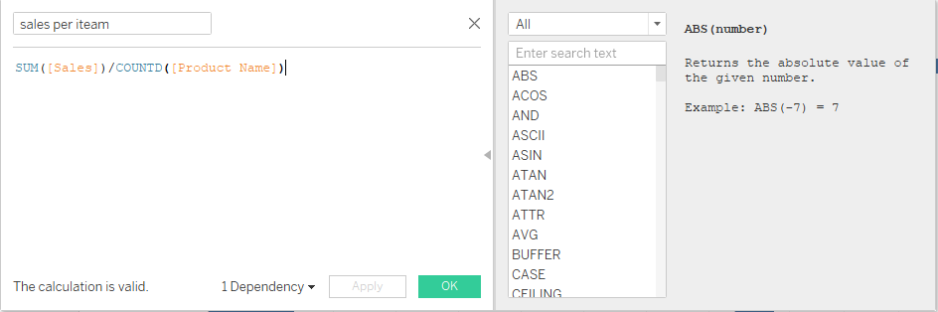

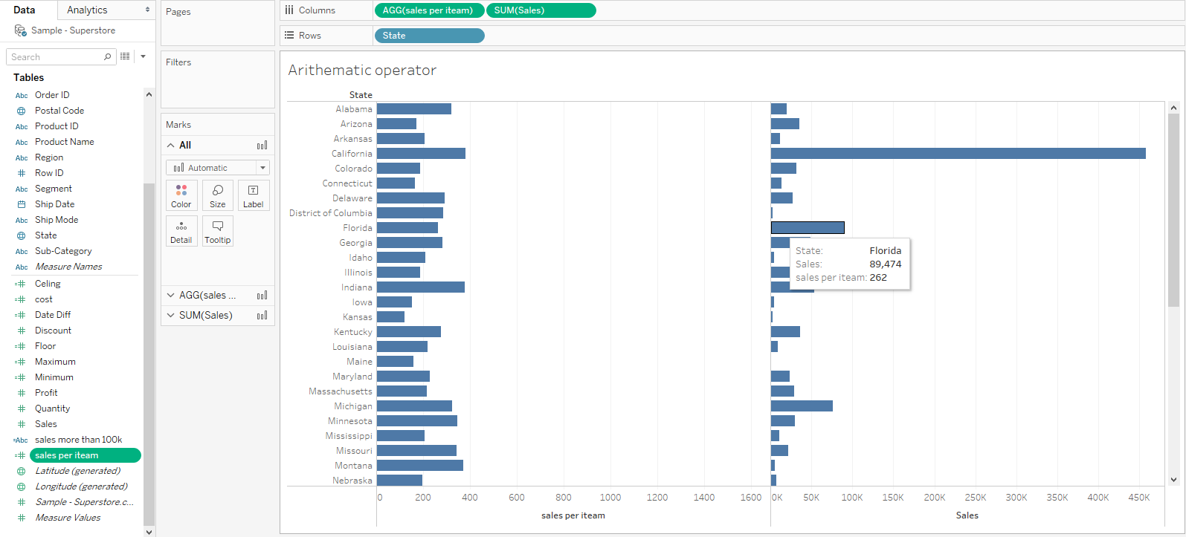

# Relational Operators/ Comparison Operators

These operators are used in expressions. Each operator compares two numbers, dates, or strings and returns a Boolean Value.

* = = or = (Equal to)

Example: 5=5

* != or <> (Not equal to)

Example: 18 != 37 / 2

* > (Greater than)

Example: [Profit] > 20000

* < (Less than)

Example: [Profit] < 20000

# LogicalOperators

These operators are used in expressions whose result is a Boolean giving the output as TRUE or FALSE.

* AND

Example: if Profit >10000 AND Sales >20000

* OR

Example: if Profit >10000 OR Sales >20000

* NOT

Example: NOT Profit >10000

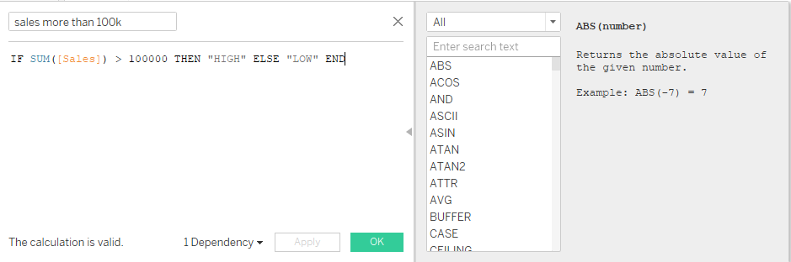

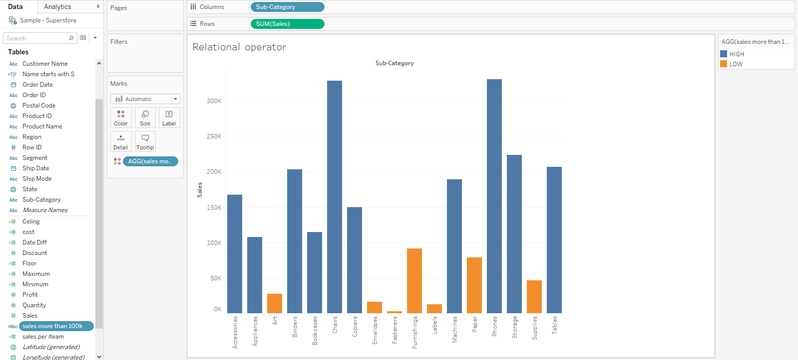

# Tableau-Functions:

In Tableau, the calculation editor is used to apply calculations to the fields being analyzed. Tableau has a number of inbuilt functions which help in creating expressions for complex calculations.

Following are the description of different categories of functions.

* Number Functions
* String Functions
* Date Functions
* Logical Functions
* Aggregate Functions

# Number Functions:

These are the functions used for numeric calculations.

* CEILING (number)

Example: CEILING(2.145) = 3

* POWER (number, power)

Example: POWER(5,3) = 125

* ROUND (number, [decimals])

Example: ROUND(3.14152,2) = 3.14

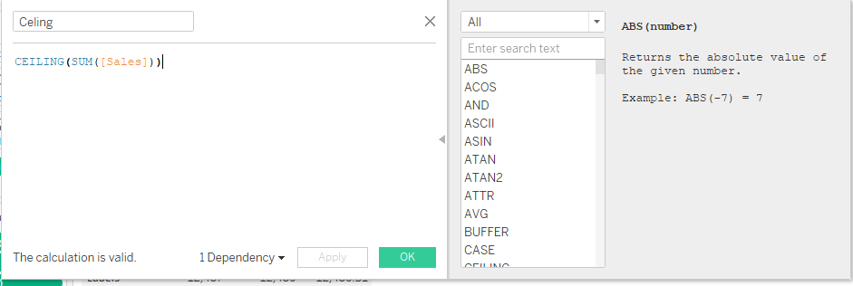

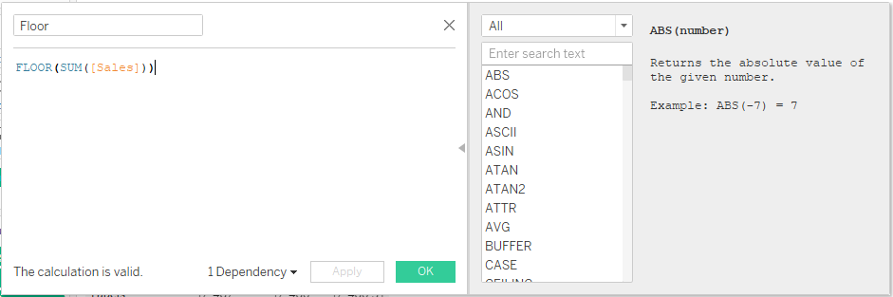

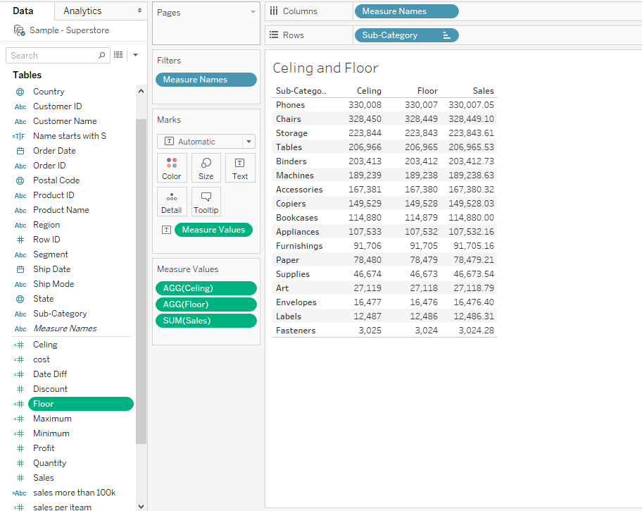

# String Functions

String Functions are used for string manipulation.

* LEN (string)

Example: LEN("Tableau") = 7

* STARTS WITH(string)

Example: STARTSWITH(“ Customer name”,”S”)

* UPPER (string)

Example: UPPER("Tableau") = "TABLEAU"

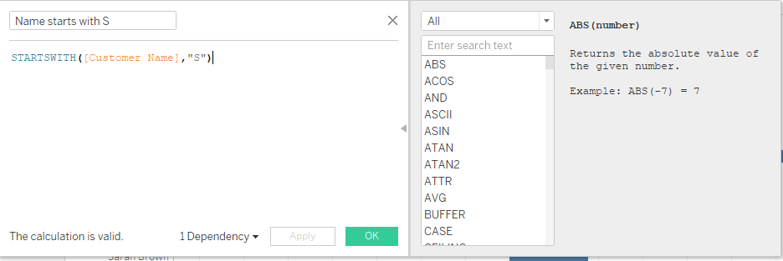

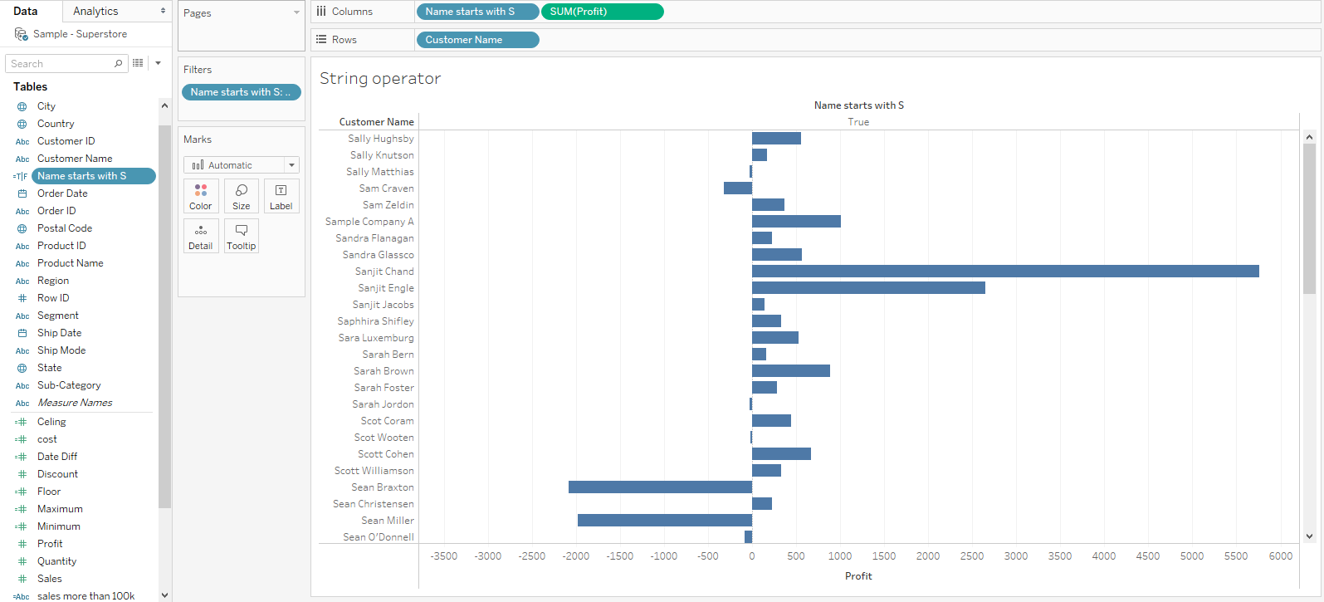

# Date Functions

All the date functions use the **date_part** which is a string indicating the part of the date such as - month, day, or year.

* DATEADD (date_part, increment, date)

Example: DATEADD ('month', 3, #2004-04-15#) = 2004-0715 12:00:00 AM

* DATENAME (date_part, date, [start_of_week])

Example: DATENAME('month', #2004-04-15#) = "April"

* DATEDIFF(date part,[Order date],[Ship date])

Example:DATEDIFF(‘day’,#2019-19-03,#2019-10-03)=9

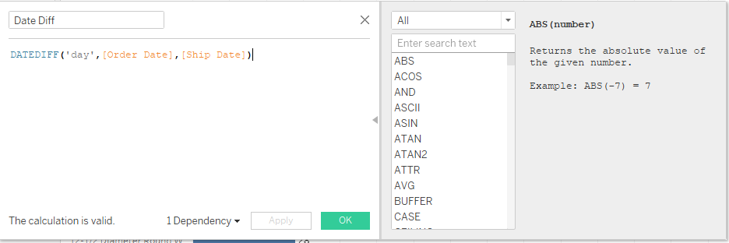

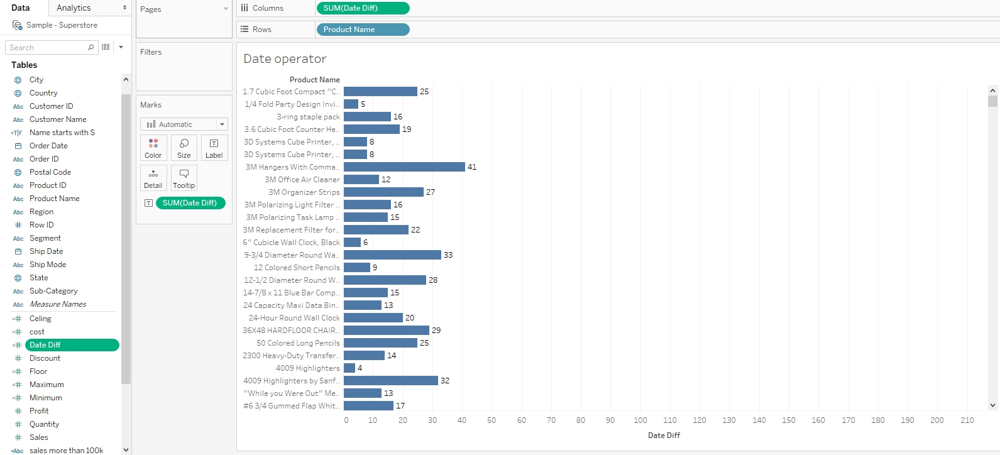

# Logical Functions

These functions evaluate some single value or the result of an expression and produce a boolean output.

* IFNULL (expression1, expression2)

Example: IFNULL([Sales], 0) = [Sales]

* ISDATE (string)

Example: ISDATE("11/05/98") = TRUE

ISDATE("14/05/98") = FALSE





# Aggregate Functions

* AVG(expression)
* Returns the average of all the values in the expression. AVG can be used with numeric fields only. Null values are ignored.
* COUNT (expression)
* Returns the number of items in a group. Null values are not counted.
* MEDIAN (expression)
* Returns the median of an expression across all records. Median can only be used with numeric fields. Null values are ignored.
* STDEV (expression)
* Returns the statistical standard deviation of all values in the given expression based on a sample of the population.

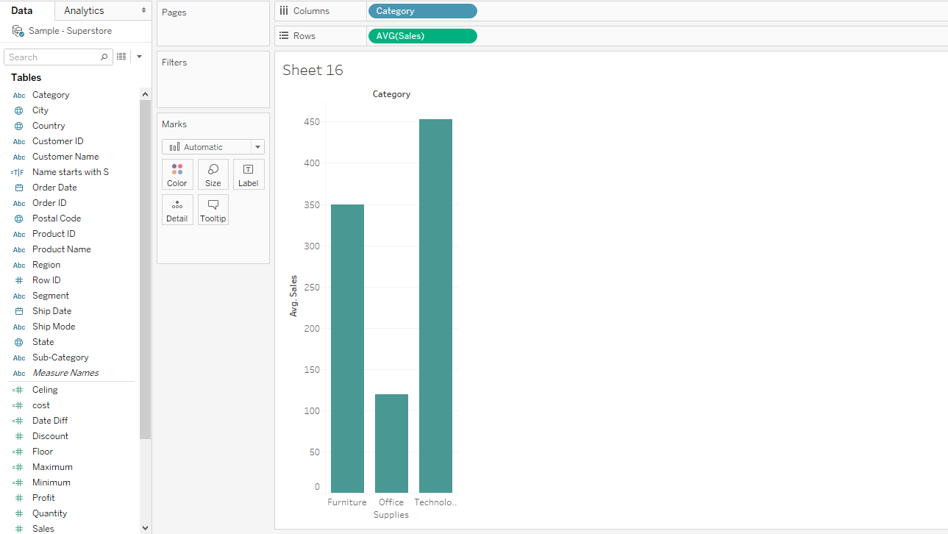

# Tableau-Table calculations

These are the calculations which are applied to the values in the entire table. For example, for calculating a running total or running average, we need to apply a single method of calculation to an entire column. Such calculations cannot be performed on some selected rows.

Table has a feature called **Quick Table Calculation**, which is used to create such calculations. The steps to be applied in Quick Table calculation are as follows −

**Step 1** − Select the measure on which the table calculation has to be applied and drag it to column shelf.

**Step 2** − Right-click the measure and choose the option Quick Table Calculation.

**Step 3** − Choose one of the following options to be applied on the measure.

* Running Total
* Difference
* Percent Difference
* Percent of Total
* Rank
* Percentile
* Moving Average
* Year to Date (YTD) Total
* Compound Growth Rate
* Year over Year Growth
* Year to Date (YTD) Growth

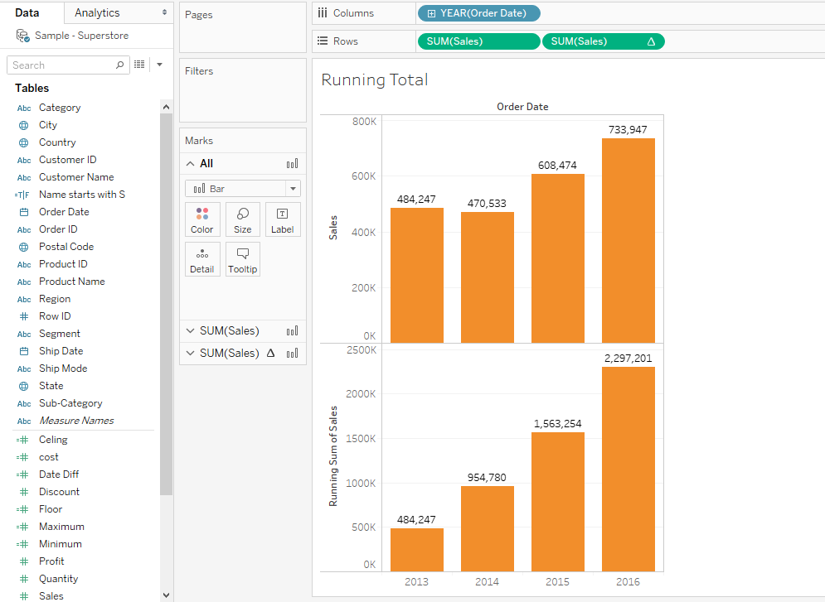

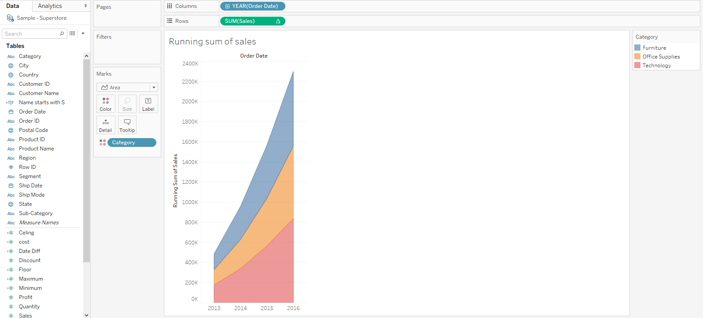

# Tableau -LOD Expressions

Level of detail (LOD): - are used to run complex queries involving many dimensions at the data source level instead of bringing all the data to Tableau interface. A simple example is adding dimension to an already calculated aggregate value.

# Types of LOD

There are three main types of LOD expressions.

* **FIXED LOD** This expression computes values using the specified dimensions without reference to any other dimensions in the view
* **INCLUDE LOD** This level of detail expressions compute values using the specified dimensions in addition to whatever dimensions are in the view.
* **EXCLUDE LOD** These levels of detail expressions subtract dimensions from the view level of detail.

# FIXED LOD

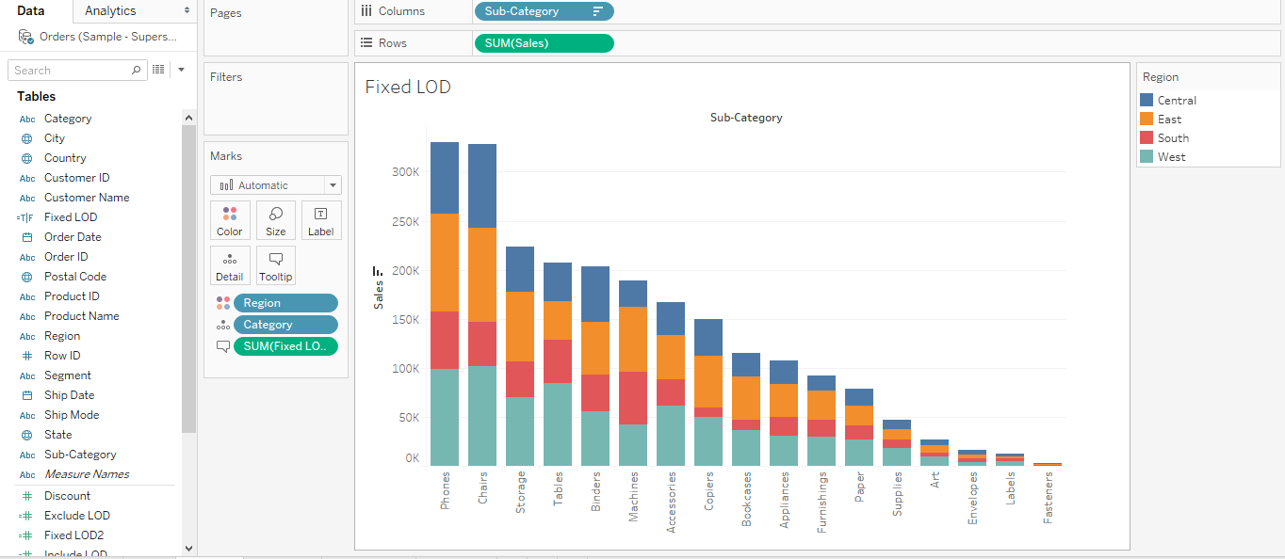

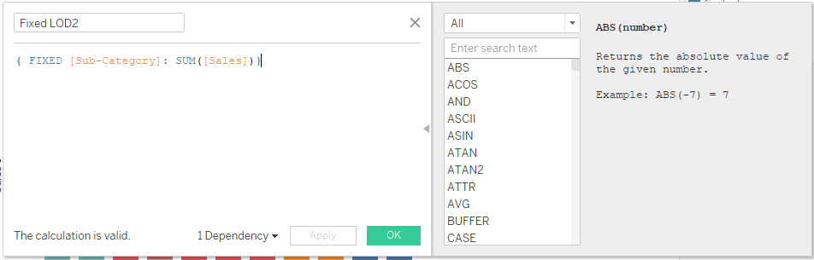

# Include LOD

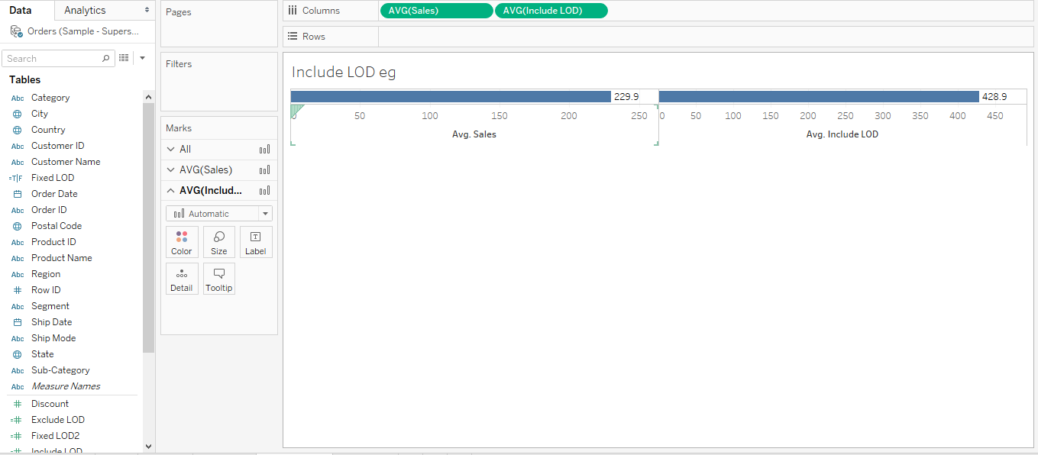

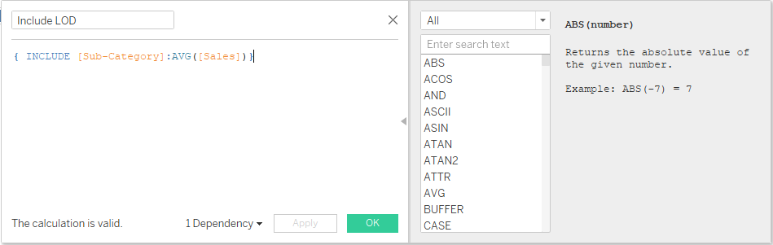

# Exclude LOD

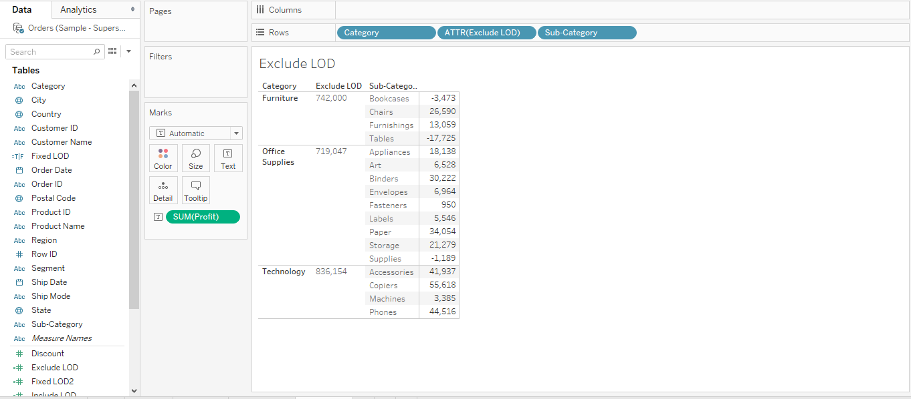

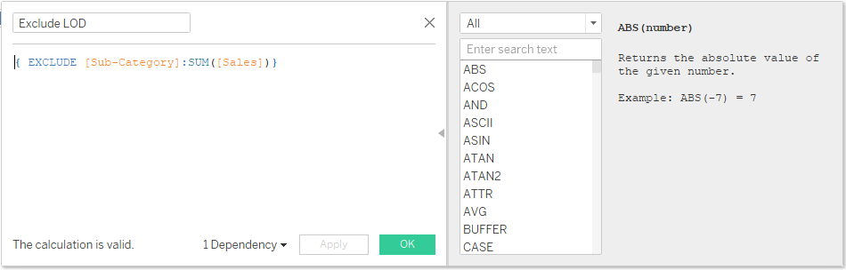

**Parameters in Tableau**

# Parameters:

A parameter is a value that can be changed by the user interacting with a view, rather than your visualizations using a constant value. Parameters allow you to give users control over the visualization.

# Ways a parameter can be used:

* User-contolled thresholds
* What-if analysis
* Dynamic field,axis,titles etc
* Filtering acorss disparate data sources
* Top N

# Data types used to create a parameter:

* Float
* Integer
* String
* Boolean
* Date
* Date and Time

# Steps to use a parameter:

* **Create the parameter**
* **Use the parameter in either a calculated filed, reference line, set or filter**

# Parameter using Integer:

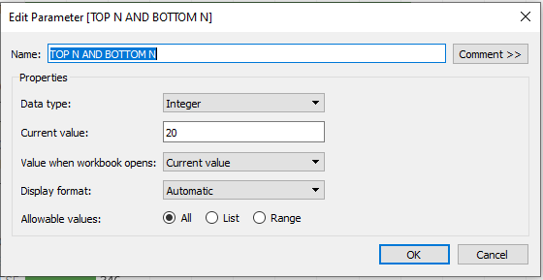

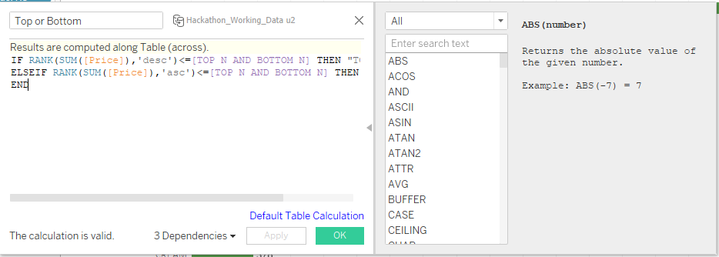

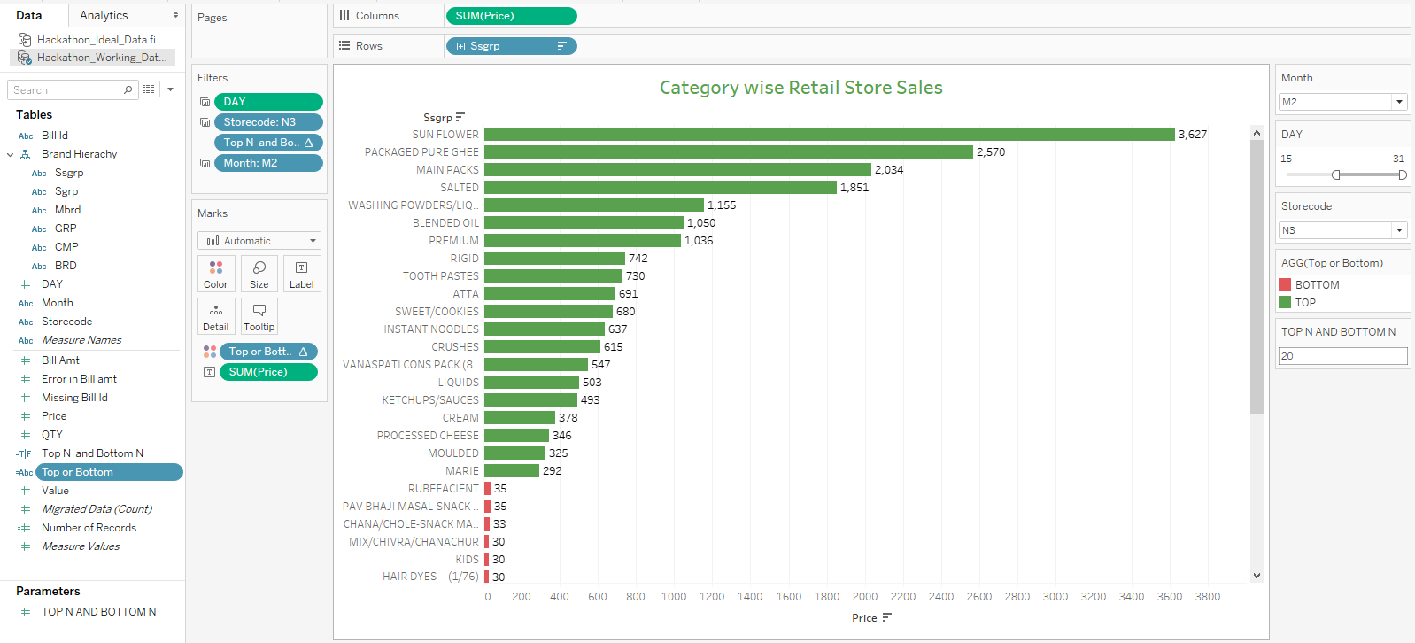

# Parameter using Float:

# 

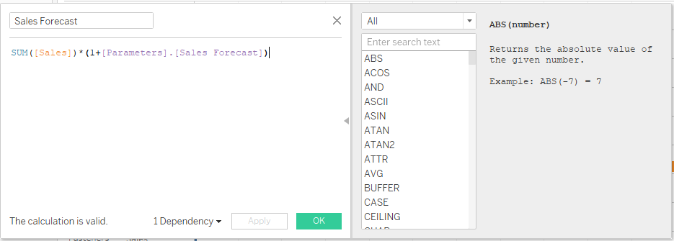

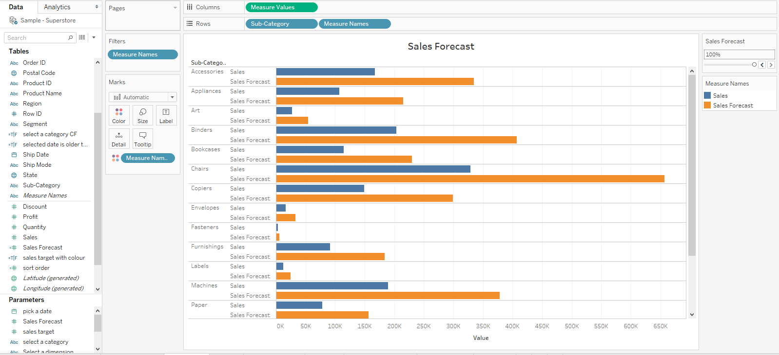

# Sales Target :

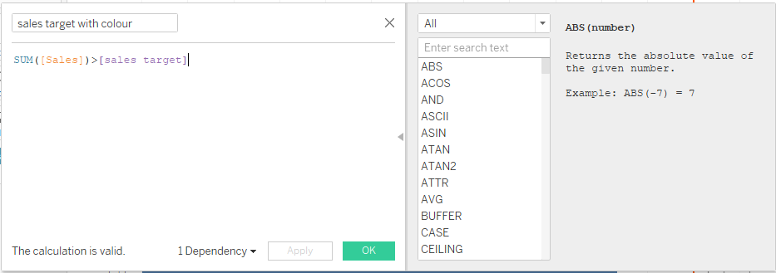

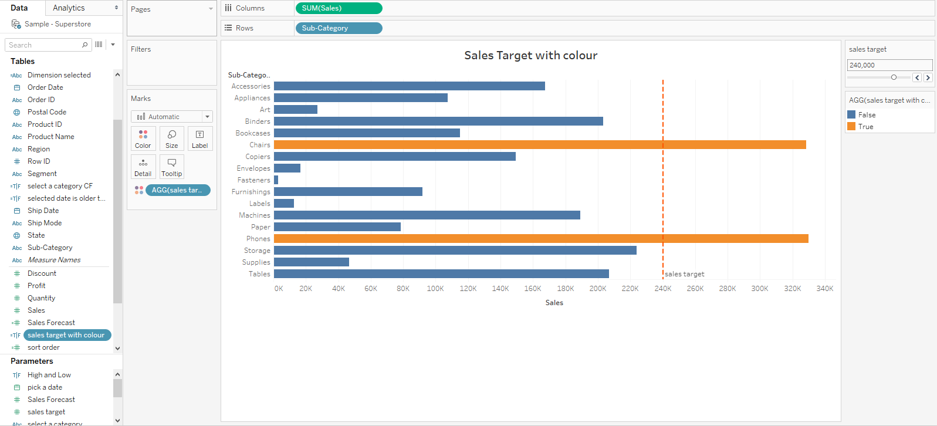

# Parameter using String:

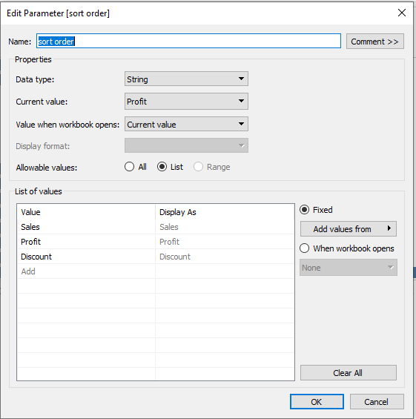

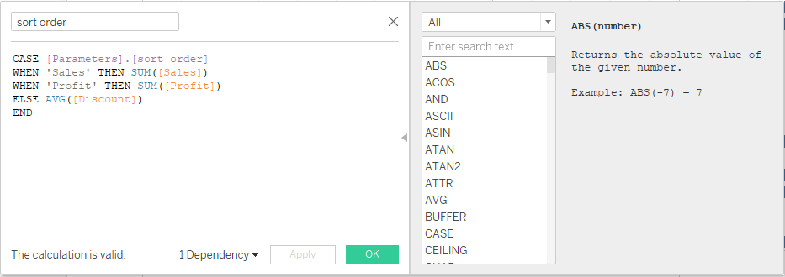

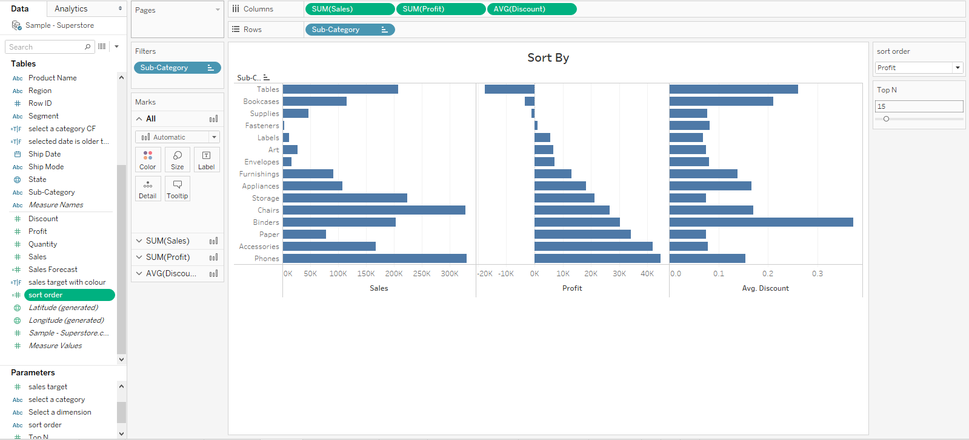

# Parameter using Date:

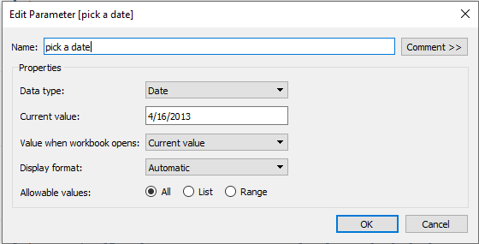

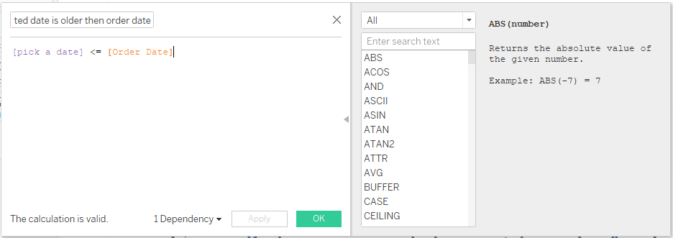

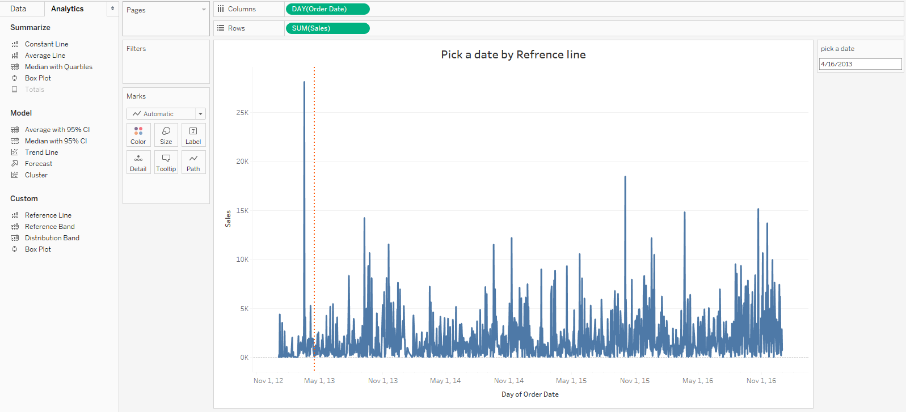

# Pick a date by RefEREnce line and Calculative field:

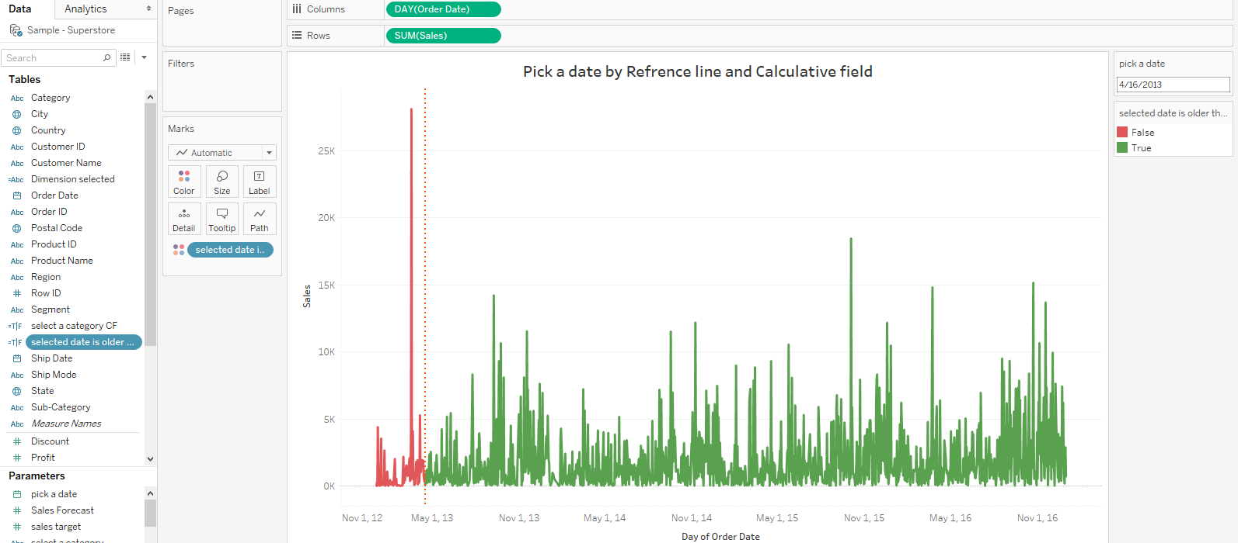

# Parameter using Boolean:

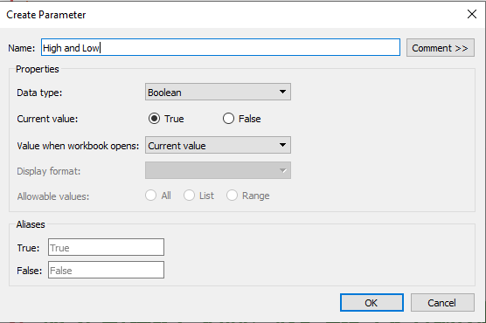





# Dynamic Dimension:

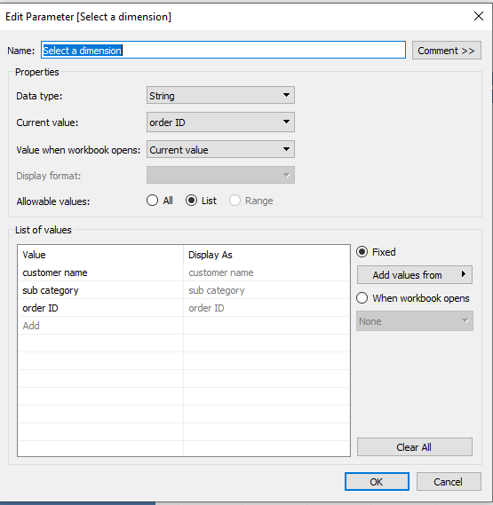

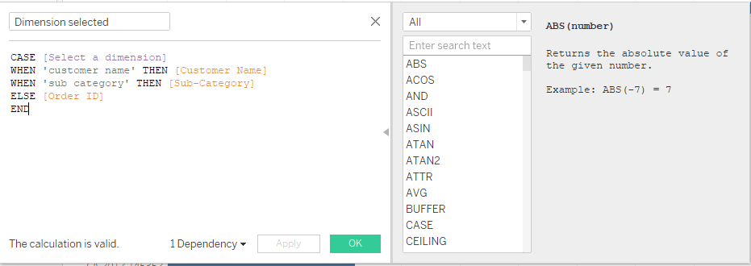

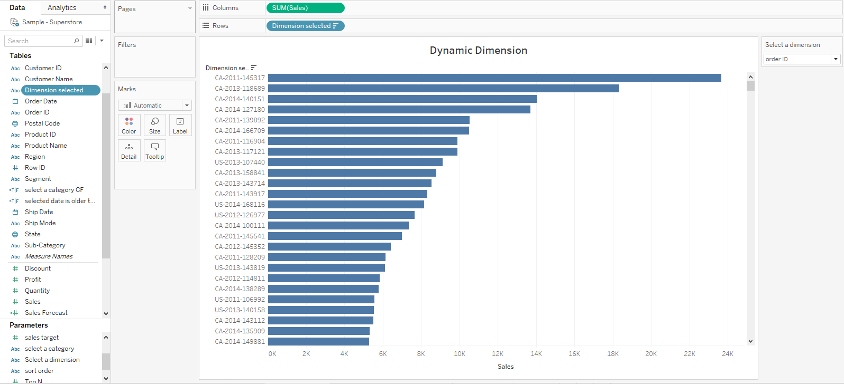

# Using a parameter to highlight the category selected:

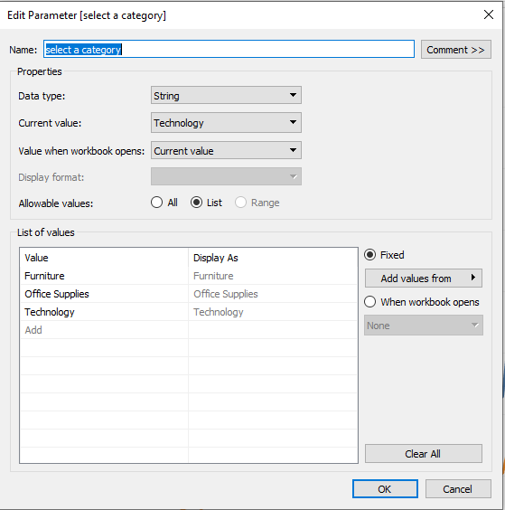

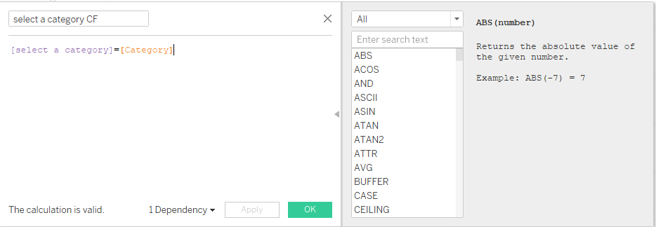

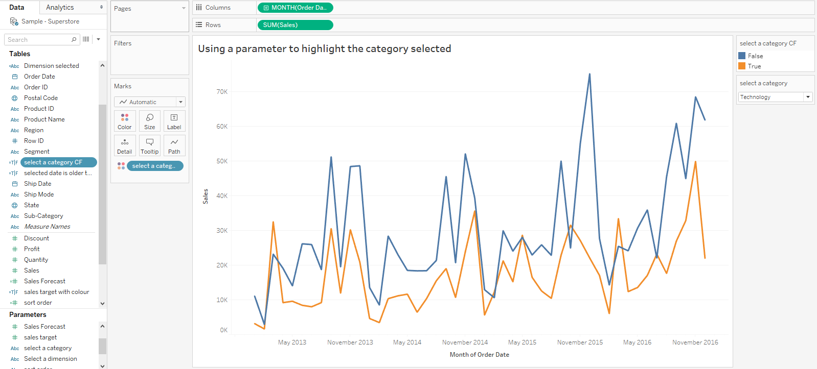

**Thank you**